Cheese

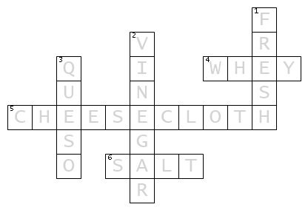
ACROSS
4. What is the liquid called for straining the curds?
5. What is used to help strain the curds and whey?
6. What ingredient helps prevent bacteria from growing?
DOWN
1. Name the type of cheese with no rind and has between 19-24% butter fat.
2. What acid is used to make Queso Blanco?
3. Blanco Name the cheese that is made from milk, salt, and vinegar.

